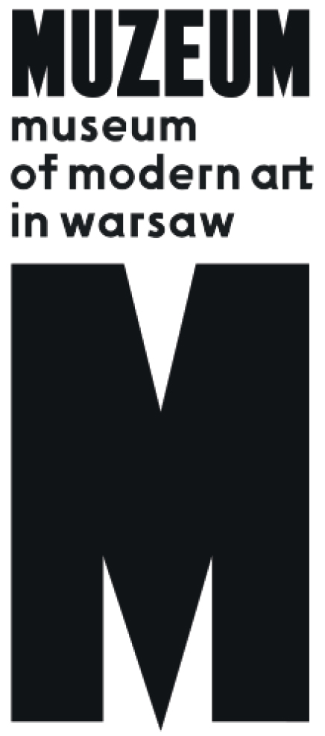 | 140 Beats per Minute  Rave culture and art in 1990s Poland  22.07 – 27.08.2017  Museum on the Vistula  Wybrzeże Kościuszkowskie 22  Warsaw

The exhibition 140 Beats per Minute explores the links between rave culture and contemporary art in Poland in the 1990s. This year’s version of the exhibition in the newly opened pavilion of the Museum on the Vistula expands the show prepared by the Museum of Modern Art in Warsaw for the Open’er Festival in Gdynia in 2016, which was funded and produced by Alter Art, the promoter of the festival.
The title is a reference to the number of beats per minute in classic techno music. Jacek Sienkiewicz, a pioneer of techno in Poland, whose works are presented in the exhibition, played in this tempo in the 90s. The term “rave” is used to refer to underground dance events with electronic music—mainly techno which took hold in Poland along with the transformation in the political and economic system in the early 1990s. On one hand they were an expression of the authentic if often naive optimism of the period of transformation. On the other hand they manifested the anxieties of those times of civilizational and technological acceleration.
The rave/techno culture was the music subculture that appeared after 80s punk, engag-ing visual artists fascinated by how the rave community came together in reaction to the neoliberal atomization, privatization and hierachization of society. It was also a new subculture, after the hippies, to show such interest in the visual. Images were as important for them as dance and music. It was the first time a dance party became an equally important medium for visual artists. Galleries became dance clubs, exhibitions turned into rave parties.

Visual artists were intrigued by a new figure present in rave culture, that of a sample artist - DJ and VJ - who creates his works live from prepared material. As opposed to previous music subcultures and artistic directions, a sample artist fights for his anonymity and contests the existing cultural hierarchies – the divisions between the revered artist and the fascinated fans. Artists interpreted techno as another incarnation of avant-garde, non-literary abstract art of constructivist provenance. By entering into a relation with rave culture, they showed interest in its technological aspect. Here, art is created mechanically. It is a reaction to the appearance of new, mass-scale technologies, such as personal computers and the internet, in the 90s. Art created in the context of rave was another chapter in the history of relations between art and technology, and a direct precursor of current post-internet art. It also offered another chapter in the history of the relationship between art and dance.

In the “140 beats per minute” exhibition we are especially interested in the role of rave in relation to the pop tendency of Polish art in the 1990s. In opposition to so-called critical art, artists creating this trend sought more inclusive, non-elitist forms of building communities through art.

The exhibition features a number of installations and documentations of the initiatives of the Tricity group CUKT (Central Office for Technical Culture), who formatted the raves they organized as pastiches of political rallies and public events, underlining their disappointment in the politics of the era of transformation. In their rave happenings like the Anti-election or Wiktoria Cukt (a virtual candidate for president), the artists stressed the agency of the individual who can organize civically, building grassroots communities to achieve change. The exhibition will also show a series of lightboxes by Marta Deskur entitled Family, devoted to the raver community, mainly DJs and VJs, which the artist was a member of in Kraków in the 1990s. It was a group of friends joined by strong emotional and spiritual ties. The events they organized were intended to reinforce those bonds. She created a number of portraits of her family of friends, assigning them the symbolic motifs known from religious painting. There will be sculptures by Marek Kijewski and Małgorzata Malinowska (Kocur). Fascinated by the figure of the DJ sampling from many different ready materials, in their sculptures they eclectically combined visual elements derived from extremely varied contexts. In the sculpture Equestrian Portrait of Andy Warhol they allude to classical presentations while combining the motifs of a centaur, a raver in fur, and a portrait of Warhol.

Artists: Paweł Althamer, Rafał Bujnowski, CUKT (Adam Virus Popek, Mikołaj Robert Jurkiewicz, Piotr Wyrzykowski, Artur Kozdrowski, Jacek Niegoda, Anna Nizio, Rafał Grabowski, Marek Jabłoński, Paweł Paulus Mazur, Andrzej Awsiej, Maciej Sienkiewicz, Rafał Ewertowski), Ewa Ciepielewska / LUXUS, Marta Deskur, Sławomir Elsner, Jarosław Fliciński, Dorota Jurczak, Mikołaj Robert Jurkiewicz, Marek Kijewski/Małgorzata Malinowska (Kocur), Karolina Kowalska, Wspólnota Leeeżeć, Grupa Ładnie, Miłosz Łuczyński, Marcin Maciejowski, Joanna Małecka, Paweł Paulus Mazur / Yach Paszkiewicz, Najakotiva, Neurobot, Józef Robakowski, Robert Rumas, Wilhelm Sasnal, Jacek Sienkiewicz, Janek Simon, Karol Suka, Agnieszka Tarasiuk, Piotr Wyrzykowski, Robert Zając, Marcelo Zammenhoff, Alicja Żebrowska, gościnnie: Gregor Różański / Mateusz Kazula, Kolektyw Terenowy.

Curators: Szymon Maliborski, Łukasz Ronduda
Curatorial cooperation: Zofia Krawiec
Exhibition design: Maciej Siuda in collaboration with Tomasz Czuban and Katarzyna Dąbkowska
Graphic design and publication: Maciej Ratajski
Graphic design, poster and video: Noviki.net
Production: Jakub Antosz, Marek Franczak, Piotr Frysztak, Szymon Ignatowicz, Artur Jeziorek, Przemysław Pryciak, Paweł Sobczak, Marcin Szubiak, Michał Ziętek
Translations: Łukasz Mojsak

Press:
Iga Winczakiewicz iga.winczakiewicz@artmuseum.pl / prasa@artmuseum.pl
Press release: prasa.artmuseum.pl

