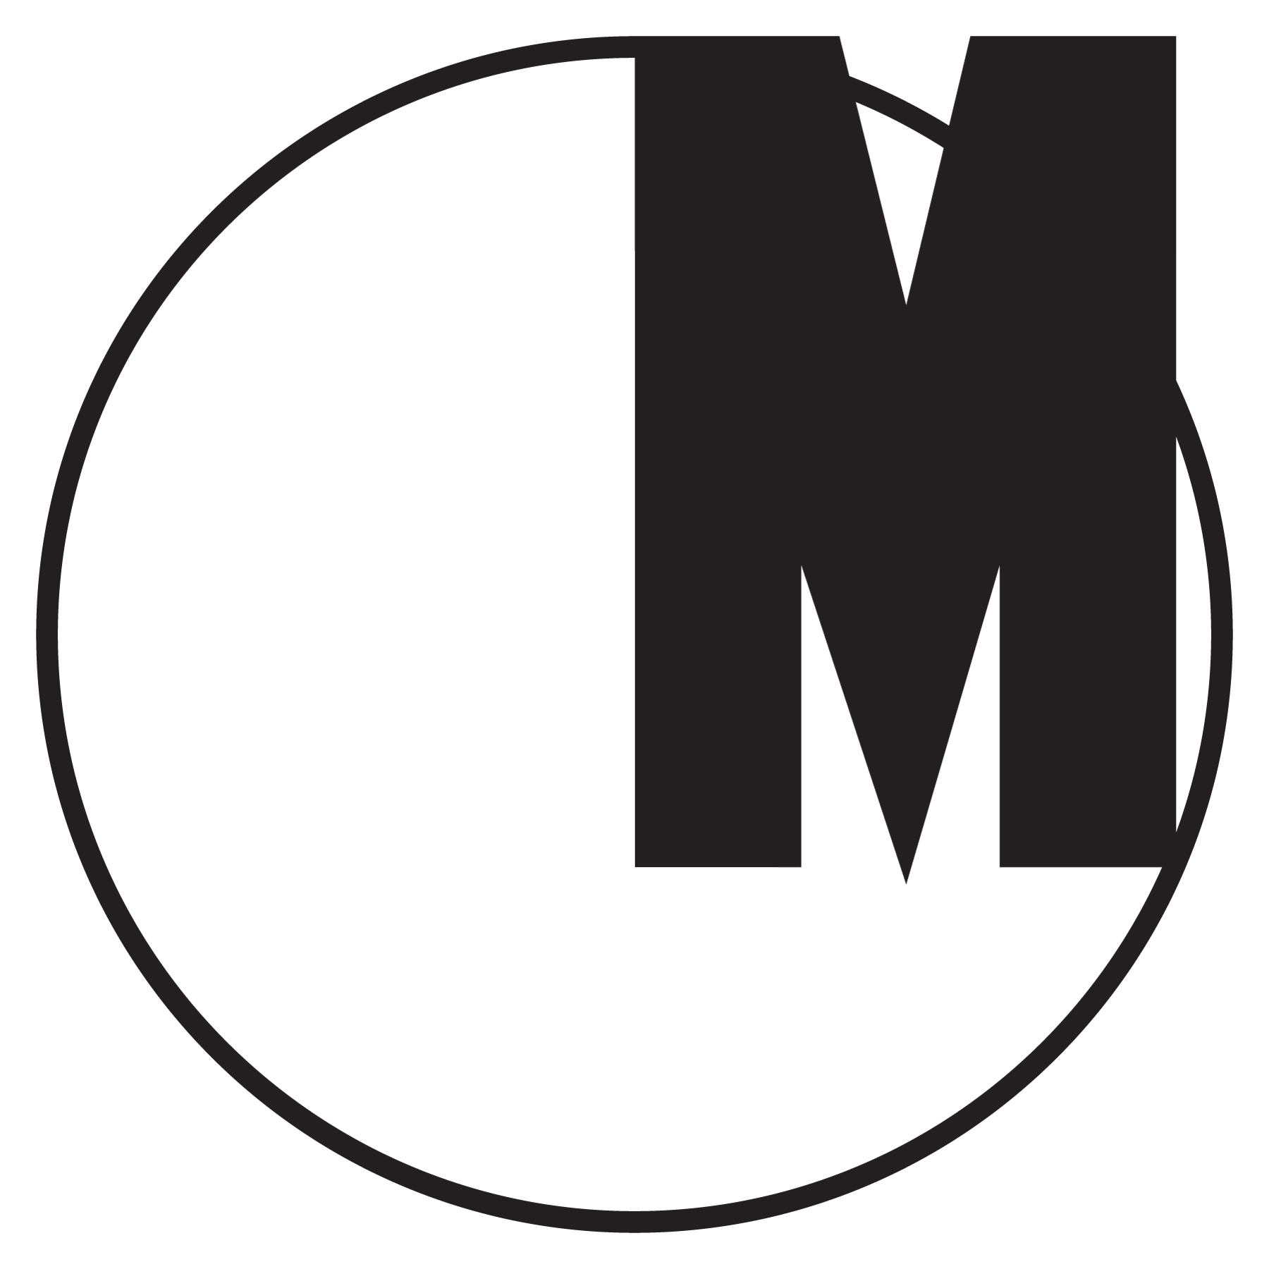

The Second Polish Exhibition of Graphic Symbols

November 10 – January 31, 2016

Opening: November 13, 2015, 7 p.m.

The Second Polish Exhibition of Graphic Symbols will present a cross-section of Polish logos and visual communication systems. The viewers will have the opportunity to take a look back at iconic designs from 1945 – 1969 and learn about the history of Polish graphic design, but also to confront the achievements of our design masters with the most recent works in this field.

The first part of the exhibition is a reconstruction of the legendary First Polish Exhibition of Graphic Symbols from 1969. Hosted by the Association of Polish Artists and Designers in Warsaw, it displayed 335 designs selected by a Qualifying Committee from a number of mailed-in applications. It included the logo designs of Pekao, Moda Polska, CPN, Unitra, Dom Handlowy “Telimena” and many other iconic images created by designers such as Ryszard Bojar, Roman Duszek, Jan Hollender, Emilia Nożko-Paprocka, Karol Śliwka or Leon Urbański.

The second part of the exhibition includes 335 recent designs created between 2000 and 2015, selected by the exhibition's Consultants' Council and Commissioners (Ryszard Bojar, Marta Gawin, Viktoriya Grabowska, Michał Łojewski, Katarzyna Roj, Kuba Sowiński, Marcina Wolny, Patryk Hardziej and Rene Wawrzkiewicz) from among 3000 submissions.

Since the late 1960s Poland has not produced an exhibition or publication that would attempt to show the history of its graphic symbols and visual identities in its entirety. A sign is one of the basic elements of visual communication. Abstract symbols, artistic metaphors and graphic shortcuts are like syllables and letters of a graphic language system in which the history of a nation or a society is reflected.

The Second Polish Exhibition of Graphic Symbols was first presented at the Design Centre in Gdynia. The Museum of Modern Art in Warsaw will host it from November 13 to January 10, 2016. In 2016 the exhibition will be taken to the BWA Dizajn gallery in Wrocław, Bunkier Sztuki in Cracow, the BWA Tarnów gallery and other galleries, museums and cultural institutions in Poland. Openings will be accompanied by lectures, workshops and various meetings.

November 14 – 15, 2015, 12 – 6 p. m.

Conference on sign and visual identity design. Participants will include Jakub de Barbaro, Edgar Bąk, Ryszar Bojar, Łukasz Dziedzic, Marta Gawin, Mamastudio, Wojtek Mierowski, Otwarte, Papajastudio, Kuba Sowiński, White Cat Studio, UVMW and Andrzej-Ludwik Włoszczyński.

Exhibition commissioners: Patryk Hardziej, Rene Wawrzkiewicz
Consultants' Council: Ryszard Bojar, Marta Gawin, Viktoriya Grabowska, Michał Łojewski, Katarzyna Roj, Kuba Sowiński and Marcin Wolny.
Cooperation: Tomasz Chądzyński, Piotr Chuchla, Ewa Chudecka, Aleksander Drożdżewski, Artur Jewuła, Tomasz Jurecki, Ksawery Kirklewski, Marta Kowalska, Adam Nowiński, Marianna Paszkowska, Patrycja Podkościelny, Marta Sarnowska, Szymon Sawicki, Jagoda Sosińska, Kaja Stępkowska, Piotr Śliżewski, Nikola Trojnar, Julek Wierzchowski, Zuzanna Zamorska.
Graphic symbol: Karol Śliwka
Main partners: Museum of Modern Art in Warsaw, BWA Dizajn Gallery Wrocław, Gdynia Design Centre, Oldschool Logo, Design-Crit
Media inquiries: info@owzg,pl
More information: www.owzg.pl/en

