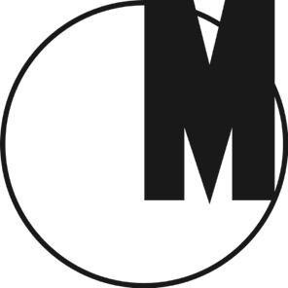

Farmhands in Factories and Boas in Brasseries

Museum of Modern Art in Warsaw
February 29 – April 3, 2016
Opening: February 29, 2016 at 6 p.m.
Curator: Ewa Tatar

“Farmhands in Factories and Boas in Brasseries” (the title is a line from Agnieszka Osiecka's song “Niech żyje bal”) examines the worker-farmer class that emerged in the People's Republic of Poland in the wake of the land reform enacted in 1944.

The communist authorities intended these “new citizens” to become the leading stratum of society and devoted considerable attention to their development, pursuing a policy of “grassroots work” that brought electricity and education to the villages. Collectivization was never fully carried out, however, and the private ownership of land and attachment to traditional values in rural areas became a key feature of the “Polish road to communism.”

The exhibition contains seventy objects arranged according to three non-chronological visual typologies. The first of these presents the moral and civilizational values promoted by soft propaganda, exemplified here by Nowa Wieś (“New Village”) – an illustrated magazine targeted at progressive youth living in small communities. The second – Władysław Hasior's “Photographic Notebooks,” published in Nowa Wieś in the 1980s – is a visual atlas tracing the way folk culture changed under the influence of the mass media. In the third, spontaneous bestiaries created by amateur artists, either inspired by genuine culture shock (Józef Piłat) or encouraged by official policy (Stanisław Marcisz), have been placed alongside state-commissioned folk art produced by professional artists, cooperatives, and artisans. In each of these narratives, realistic calls for modernization and progress coincide with an often sentimental romanticism relating to a world that has since disappeared. The exhibition looks at areas of often unrealized violence, and the way these were creatively worked through in art.

Venue:
Museum of Modern Art in Warsaw
ul. Pańska 3, Warsaw, Poland
www.artmuseum.pl

Opening hours:
Every day 12 p.m.–8 p.m.
Admission free

Press contact:
prasa@artmuseum.pl

