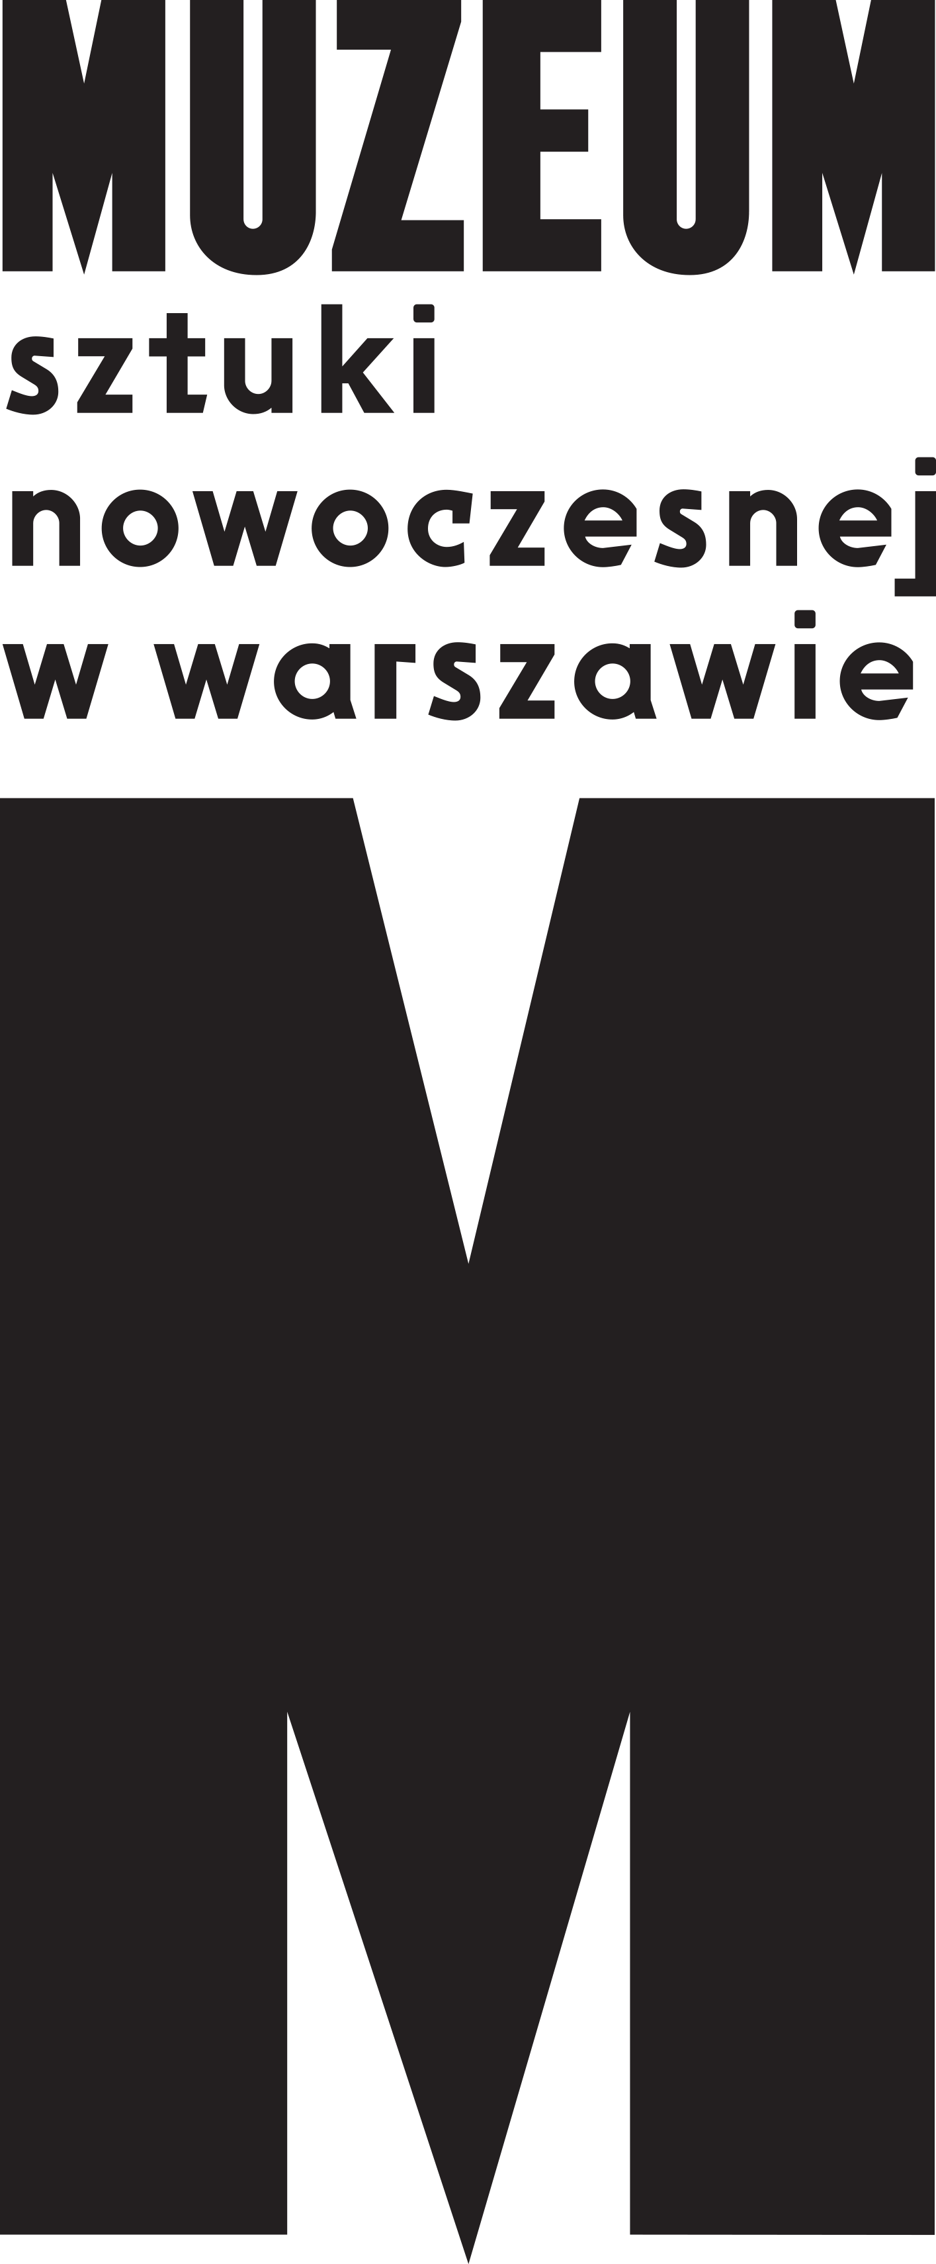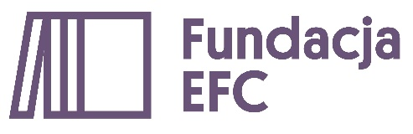 | PRESS INFO  „Fundamental Forms”  Organizers:  Muzeum Sztuki Nowoczesnej w Warszawie  Edukacyjna Fundacja im. Romana Czerneckiego  2021/2022

What can we do with art?
Ten schools and ten exhibitions hidden in ten boxes. At the invitation of the Museum of Modern Art in Warsaw, an international group of artists have prepared special works for Polish primary schools. The exhibition becomes a model to assemble: do it yourself, or let’s do it together!
Along with the Roman Czernecki Educational Foundation, the Museum of Modern Art in Warsaw has prepared a new programme of artistic cooperation entitled Fundamental Forms. The pilot edition will be held during this year’s 13th edition of the WARSAW UNDER CONSTRUCTION festival under the title “How to make a school?” which will be entirely devoted to design for education. Sebastian Cichocki and Helena Czernecka invited 10 Polish and foreign artists and collectives—including Slavs and Tatars, Goshka Macuga, Ramona Nagabczyńska and Sharon Lockhart—to prepare instructions for execution of artworks or elements for assembling them. Ten small boxes with instructions will be included in a single larger box, resembling an architectural model of a school building. They will go to 10 primary schools all over Poland so that, along with their teachers, pupils from grades 4–8 can prepare their own exhibitions.
“We were inspired by the programme School Prints, launched in the UK after the stormy years of the Second World War,” explained Sebastian Cichocki, chief curator at the Museum of Modern Art in Warsaw. “Portfolios were created then with unique lithographs by Barbara Jones, Henri Matisse and Pablo Picasso, which were displayed on the walls of classrooms and school corridors. We were intrigued by what happens with art outside the museum, when it becomes part of everyday life, learning and fun.”
Fundamental Forms is an invitation to youngsters to enter the role of artists creating works as well as curators preparing various exhibitions from those works. The project also alludes to initiatives within an educational setting by such artists as Joseph Beuys, Cornelius Cardew, Jef Geys, Anna Halprin, Oskar Hansen, Asger Jorn, and K.G. Subramanyan.
Helena Czernecka, curator of the programme, added: “The boxes contain a ‘dormant’ exhibition which can materialize at any time. The format of exercises, tasks and tools enclosed in a box also alludes to the work of Marcel Duchamp and his travelling exhibition-in-a-suitcase, as well as ‘Fluxkits’—boxes prepared by artists affiliated with the Fluxus movement.” Fundamental Forms encourages pupils to look at their own school from a distance, to change the scale, to rediscover the interiors and surroundings of the building. The exhibition will arise within school spaces, in classrooms and corridors, gyms and playgrounds. It can be executed numerous times and interpreted in various ways (in the selection of fragments, scale, colours, etc). With Fundamental Forms, we pose the questions: What can we do with art? What can an exhibition be? Where and when does it begin and end? What can we learn from artists? And finally, what knowledge can we gain from contact with art? How to understand art, or enjoy the experience of not understanding it?
Artists taking part in Fundamental Forms: Paweł Althamer, Kasper Bosmans, Gabo Camnitzer, Sharon Lockhart, Goshka Macuga, Olga Micińska, Mikołaj Moskal, Ramona Nagabczyńska, Agnieszka Polska, Katarzyna Przezwańska, Slavs and Tatars
Curatorial team: Sebastian Cichocki, Helena Czernecka
Box design: Michał Sikorski TŁO
Graphic designs: Zofia Kofta
Choreographic cooperation: Alicja Czyczel
Production team: Maja Raczyńska-Kaczmarek, Marta Wójcicka
Conception and coordination of educational process: Anna Grajewska, Marta Przybył
Educators: Alicja Czyczel, Aleksandra Górecka, Magda Kreis, Marta Maliszewska, Barbara Mołas, Marta Przybył, Zofia Świąder, Marta Węglińska (Kobalt Migrating Platform), Katarzyna Witt, Hanna Zwierzchowska
Teachers: Anna Broda, Zyta Czechowska, Joanna Konieczna, Magdalena Kotara-Marmur, Urszula Leks, Maryla Moździer, Paulina Pruszyńska, Edyta Rusak, Damian Sołtykiewicz, Iwona Węglowska
Schools: Special Schools Group, Kowanówko; Primary School, Pogorzałki; Primary School, Rozdrażew; Primary School no. 380, Warsaw; Primary School no. 143, Warsaw; Primary School, Zakręt; Integration Schools Group no. 62, Warsaw; Primary School no. 351, Warsaw; Social Primary School, Szczekociny

Contact for press:
prasa@artmuseum.pl
