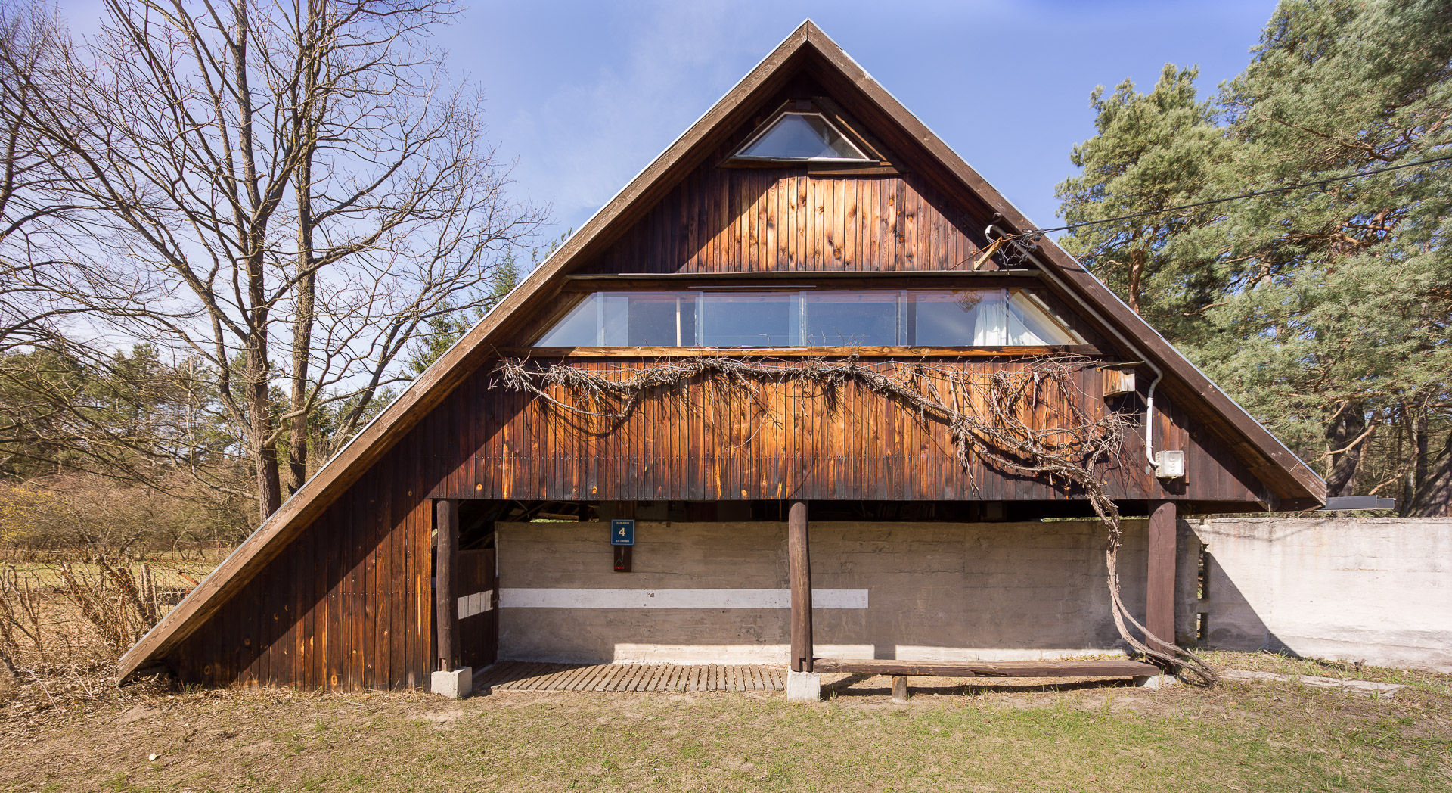

photo by Jakub Certowicz, 2015

As of the end of 2017, the Museum of Modern Art in Warsaw became the owner of the Hansens’ house in Szumin.
The next season of tours for visitors to the house will begin in the spring of 2018, along with inventory and conservation work. The purchase was made possible by a grant from the Ministry of Culture and National Heritage.
The house in Szumin belonged to the architect couple Zofia and Oskar Hansen, who began construction of the house in 1968. It is regarded as a spatial manifesto of Open Form—the concept which served Oskar Hansen as the axis of his architectural, artistic and teaching practice. The building has a characteristic layout, with a smooth flow between interior and exterior enabling easy adaptation to the changing needs of the users.
The architecture of Open Form functions as a framework for life and work only when users take advantage of its possibilities. The Hansens’ house encourages active engagement with the space, which is why it has worked splendidly as a location for plein-air exercises by the Bergen School of Architecture and more recently the Faculty of Design at the Warsaw Academy of Fine Arts. Since it was opened to visitors in 2014, it has become a magnet for architecture aficionados. The Museum of Modern Art in Warsaw will strive to maintain the aura of this place, enabling full use of its architectural qualities through organization of workshops, seminars and plein-air artistic events. The Hansens’ house will continue to encourage reflection on art and architecture.

Important information:
Note that the house is open to visitors only on certain days of the year. The schedule of upcoming spring and summer tours organized by the museum will be announced in late March. Contact: info@artmuseum.pl, (+48) 22 596 40 10.

