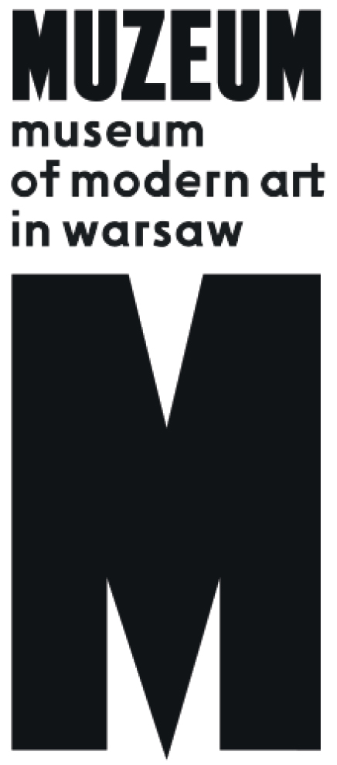 | PRESS INFO, 09.05.2022  The Dark Arts:  Aleksandra Waliszewska  and the Symbolism from the East and North  03.06 – 02.10. 2022  Wybrzeże Kościuszkowskie 22  Warsaw

Museum of Modern Art in Warsaw invites you to the opening of the exhibition "The Dark Arts: Aleksandra Waliszewska and the Symbolism from the East and North” on the 3rd of June to the Museum on the Vistula.

In her Warsaw studio, Aleksandra Waliszewska creates vivid, atmospheric paintings that speak to a massive international audience. Her work appeals equally to museum and gallery audiences, as well as to her wide international following on social media. The artist’s popular reach can be attributed to the power of her visual storytelling. Waliszewska’s figurative art is rooted in numerous sources – gothic stories, pagan mythology, and motifs borrowed from mediaeval manuscripts. Her pictorial world is populated with upiórs (the Slavic term for the living dead), vampires, possessed girls, bloodthirsty zombies, lady knights on horseback and human-like cats.
Entitled „The Dark Arts”, this exhibition is the most extensive public display of Aleksandra Waliszewska’s works to date. Working closely with the artist, the show’s curators have chosen to display iconic examples of her vast oeuvre alongside historical works of other artists. The exhibition invites the viewer to see her mythological tropes, apocalyptic scenarios, and charged landscapes in a broader context. The settings of her paintings – forests and swamps, lost highways, and gloomy housing estates—evoke the specificity of Polish and Baltic landscapes. Waliszewska’s works seem to operate using the logic of dreams and her themes conjure to primal emotions: love, desire and fear of death.
„The Dark Arts” allows the viewer to plunge into the artist’s fantastical visual universe while also pointing to her indebtedness to art history, specifically the Symbolist movement from the turn of the twentieth century. Symbolism emerged as a decadent response to the imminent collapse of the old-world order; this timely movement resonates with our own alarmist era of mega-change and global instability. Waliszewska's admiration for artists beyond the Western European art history canon forms basis of the exhibition’s transhistorical dialogue—featuring impressive examples of Polish, Czech, Ukrainian and Baltic Symbolist works. The Dark Arts features works by Mikalojus Čiurlionis (Lithuanian), Jaroslav Panuška (Czech), Kristjan Raud (Estonian) or Teodors Ūders (Latvian) among many others. Of particular importance to Waliszewska are certain Polish forbears, including Bolesław Biegas, Mieczysław Jakimowicz, Edward Okuń, Jan Rembowski, Marian Wawrzeniecki and Witold Wojtkiewicz who are prominently featured in the display. Also present are members of the artist’s family—her great-grandmother, a famous children’s author, her sculptor grandmother, and artist mother. From an early age, Waliszewska was steeped in various methods of storytelling through images and the direct contribution of this unusual artist family will be foregrounded for the first time in this exhibition.
Visitors will see over one hundred and thirty works by Aleksandra Waliszewska (including never before exhibited oil paintings) and over eighty historical works that contextualize and give historical perspective on her unique art practice.

***
Exhibited artists
Aleksandra Waliszewska
Maria Anto, Bolesław Biegas, Wanda Bibrowicz, Erna von Brinckmann, Bernhard Borchert, Mikalojus Konstantinas Čiurlionis, Frans Crabbe van Espleghem, Anna Dębska, Kazimiera Dębska, Emīlija Gruzīte, Marian Henel, Mieczysław Jakimowicz, Marcė Katiliūtė, Theodor Kittelsen, Erich Kügelgen, Konstanty Laszczka, Bronisław Linke, Mykola Murashko, Teofil Ociepka, Edward Okuń, Jaroslav Panuška, Juozas Pjaulokas, Aleksander Promet, Yevmen Pschechenko, Kristjan Raud, Vaclovas Ratas-Rataiskis, Jan Rembowski, Hugo Simberg, Gustavs Šķilters, Karel Šlenger, Nikolai Triik, Teodors Ūders, Vitkauskas, Joanna Waliszewska, Marian Wawrzeniecki, Witold Wojtkiewicz, Andrzej Wróblewski, Rihards Zariņš, Bogdan Ziętek, Antanas Žmuidzinavičius, Stefan Żechowski

The Dark Arts: Aleksandra Waliszewska and the Symbolism from the East and North
3.06 – 2.10.2022
Museum on the Vistula
Wybrzeże Kościuszkowskie 22, Warsaw

Opening hours
Tuesday—Friday 12 p.m. – 8 p.m.
Saturday 11 a.m. – 8 p.m.
Sunday 11 a.m. – 6 p.m.

Media contact:
Józefina Bartyzel | jozefina.bartyzel@artmuseum.pl | +48 695 492 970
Press kit:
prasa.artmuseum.pl
Museum of Modern Art in Warsaw:
artmuseum.pl
Exhibition guide:
waliszewska.artmuseum.pl

Partners of the Exhibitions: Lithuanian Culture Institute, Friends of the Museum of Modern Art in Warsaw, Huncwot
The Museum is funded by Ministry of Culture and National Heritage
The premises and selected projects are funded by the City of Warsaw
Patrons of the Museum and the Collection: EY, Allegro
Strategic Partners of the Museum: Ergo Hestia, Hestia Artistic Journey Foundation
Legal advisor: DZP
Media cooperation: „Pismo. Magazyn Opinii”, „Notes Na 6 Tygodni”, „Zwierciadło”

