PRESS RELEASE  Thoughts Isolated.  The Foksal Gallery Archives 1966–2016  April 26th - June 4th  Address: Pańska 3, 00-124 Warsaw  Opening of the exhibition 26th of April, 19.00  Free entry | 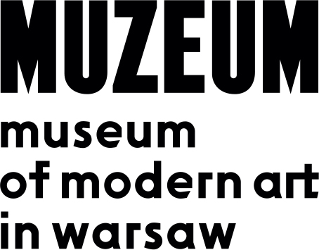

The exhibition "Thoughts Isolated: The Foksal Gallery Archives 1966–2016" presents a selection of items from the archive and collection of one of Poland’s most important art galleries, the cradle of the postwar Polish avant-garde, operating since 1966.
The exhibition premiered at the James Gallery at the Graduate Center of the City University of New York in November–December 2016. It was created in close cooperation between three curators, Katherine Carl (James Gallery, CUNY), Katarzyna Krysiak (Foksal Gallery, Warsaw) and David Senior (MoMA, NY), to mark the 50th anniversary of the founding of the Foksal Gallery in Warsaw. With a few modifications, the exhibition at the Museum of Modern Art in Warsaw is a reprise of the New York show.
The instigators of the gallery were artists Zbigniew Gostomski, Tadeusz Kantor, Edward Krasiński, Roman Owidzki and Henryk Stażewski, and art critics Wiesław Borowski, Anka Ptaszkowska and Mariusz Tchorek. The founders’ goal was to seek out and accent radical phenomena of contemporary art and to provide artists space and means to realize their experimental initiatives. A major assumption also was to create an international perspective for Polish art and to develop direct contacts with artists and art institutions abroad. This resulted in numerous presentations of artists regarded today as leading figures on the contemporary art scene and wide recognition of the Foksal name around the world.
The selected archival materials present the gallery as a model arts space run in collaboration between artists and critics, constantly in critical dialogue with itself over the purpose and meaning of its own mission. The exhibition includes print materials, such as early exhibition catalogues, invitations, posters and flyers, often designed by the artists themselves, and other archival materials such as original mockups and designs for exhibitions, and a large amount of photographic documentation of performances, installations and social gatherings at the gallery. These are supplemented by audiovisual recordings of early happenings and events.
The theoretical writings of the core critics who formed Foksal’s philosophical agenda -Wiesław Borowski, Anka Ptaszkowska, Mariusz Tchorek and Andrzej Turowski - were provocations to rethink how art could be presented, emphasizing new artistic concepts that changed how art could occur and spread. Their key texts form part of the enduring legacy of the Foksal Gallery, and this exhibition pays homage to their theoretical rigor.
The title of the exhibition, Thoughts Isolated, is drawn from a text entitled “The Living Archives” by Wiesław Borowski and Andrzej Turowski from 1971, in which they stated in bold text, WE DO NOT REPRESENT HISTORY BUT ISOLATE THOUGHTS. This text is part of a consistent examination of the idea of an archive in the program of the Foksal Gallery. From the early days, the archive was a recurring conceptual figure in the gallery’s program, including when a set of archival documents was submerged at sea as part of Tadeusz Kantor’s "Panoramic Sea Happening" in 1967 or when the gallery itself was transformed into an information exchange for international conceptual art documents during Borowski and Turowski’s "Living Archives" exhibition in 1971. The exhibition of the archive now is a process of tracing the various ways the archive was staged throughout the history of the gallery, most notably in the traveling exhibition to Edinburgh, Glasgow and London in 1979–1980.
In its current state, housed in the same small gallery space in Warsaw in wooden boxes designed by the artist Krzysztof Wodiczko in the 1970s, the Foksal Gallery Archive demonstrates the role played by the gallery in shaping the history of contemporary Polish art. These materials evidence the experimental nature of the works displayed at the gallery by Polish artists like Stanisław Dróżdż, Zbigniew Gostomski, Tadeusz Kantor, Jarosław Kozłowski, Edward Krasiński, Maria Stangret and Krzysztof Wodiczko. The archive offers a singular collection of records of immense value in both artistic and historical terms, and documents fifty years of work under various political realities and in collaboration with a diverse range of artists, from Henryk Stażewski, pioneer of the Polish avant-garde, to an international roster of conceptual artists like Christian Boltanski, Daniel Buren, Ben Vautier and Lawrence Weiner.
From its founding, the Foksal Gallery has been a non-commercial space. As a state institution, it has undergone various rounds of reorganization ordered by the authorities. Until 1984 it functioned within the Art Studios state enterprise, and subsequently under the Warsaw Bureau of Art Exhibitions. Currently it is a unit of the Mazovia Institute of Culture.

Colophon of the Exhibition:
Curators:
Katherine Carl, Katarzyna Krysiak, David Senior

Collaboration:
Robert Jarosz, Martyna Stołpiec

Production:
Szymon Maliborski

Installation:
Jakub Antosz, Jonasz Chlebowski, Michał Ziętek

