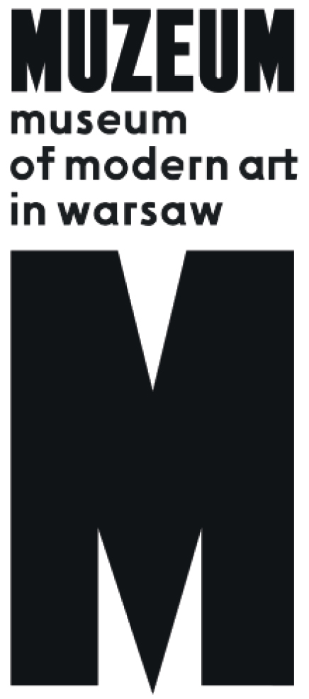 | PRESS RELEASE  Oskar and Zofia Hansen  Open Form  15.09.2017– 29.10.2017  Museum on the Vistula  Wybrzeże Kościuszkowskie 22

The exhibition of Oskar and Zofia Hansen’s legacy showcases various aspects of the Open Form theory, which was the axis of their architectural, artistic and educational work.

Presented by Oskar Hansen during the International Congress of Modern Architecture (CIAM) held in Otterlo in 1959, the theory of Open Form proposed to open architecture up to its users and allow them to co-create it. Hansen fought against what he defined as Closed Form, that is fully designed structures leaving no space for users’ creativity and constituting rather a monument to their authors than a comfortable living space. Instead, Hansen put forward a radical change in the perception of the architect’s role which, in his opinion, should consist in creating a passepartout, a background for everyday life. The mission of architecture should be showcasing people and the richness of their daily activity in space. Architecture should highlight subjectivity and create a framework for individual expression, become an instrument that can be used and transformed by its users and that can easily adapt to their changing needs.

Oskar Hansen expanded on the concept of Open Form in projects of varying scale: from designs of temporary exhibition pavilions and residential estates to the Linear Continuous System, a design of linear cities stretching across the entire territory of Poland, from the Baltic to the Tatras. His wife, Zofia Garlińska-Hansen (1924–2013), was the co-author of many of these designs, in particular the residential estates that were built. Affiliated with the Warsaw Residential Cooperative, she typically remained in her husband’s shadow, but he often stressed her involvement in creating Open Form.

The exhibition displays various areas and scales of creative activity in which Open Form was applied. Background of Events focuses on designs for exhibitions and pavilions, which offered an ideal ground for theoretical experiments due to their ephemeral character. Politics of Scale focuses on Oskar Hansen’s urban planning projects, displaying their socio-political dimension. The Individual in the Collective treats the Hansens’ realized residential estates in Warsaw and Lublin, presenting their lesser-known, often unpreserved details. Architecture as an Instrument focuses on designs for public buildings: museum, gallery, theatre, recording studio—whose shape was to be determined by the users. Active Negative shows the private space of the Hansens and the concept associated with them of sculptural presentation of architectural interiors. Anti-monument describes the space-time design for the Road memorial to the victims of Auschwitz-Birkenau, a group work that became the sculptural reflection of Open Form. Exercises from Hansen’s studio at the Faculty of Sculpture at the Warsaw Fine Arts Academy are mixed into parts of the exhibition. Hansen taught at the academy for 30 years, promoting the tenets of Open Form among his students.
The event held by the Museum of Modern Art in Warsaw is the fourth edition of the exhibition prepared by Soledad Gutiérrez, Aleksandra Kędziorek and Łukasz Ronduda. It has already been presented in MACBA, Barcelona (2014), Serralves Museum, Porto (2015), and Yale School of Architecture, New Haven, US (2016). The Warsaw edition constitutes the culmination of the exhibition’s international tour.

Colophon:
Curator: Aleksandra Kędziorek
Exhibition design: Centrala (Małgorzata Kuciewicz, Simone De Iacobis)
Graphic design: Piotr Chuchla
Production: Joanna Turek in collaboration with Sylwia Borowska
Educational programme: Katarzyna Witt
Publication: Kacha Szaniawska

Website: hansen.artmuseum.pl

Opening hours: Tuesday-Thursday 12.00-20.00, Friday 12.00-22.00, Saturday 11.00-20.00, Sunday 11.00-18.00, Monday – closed.

Contact for press:
Iga Winczakiewicz iga.winczakiewicz@artmuseum.pl / prasa@artmuseum.pl
tel. 22 596 40 23
Press Release: prasa.artmuseum.pl

