“Ministry of Internal Affairs: Intimacy as Text”  26 January –2 April 2017  Opening: 26 January 2017, 19:00  (Thursday)  Museum of Modern Art in Warsaw  Pańska 3, 00-124 Warsaw, Poland  admission free | 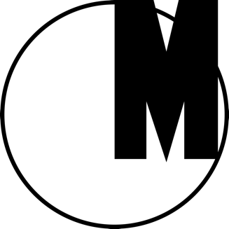

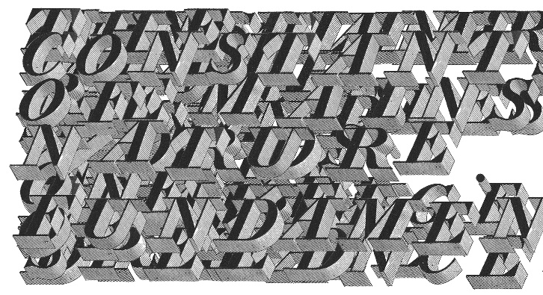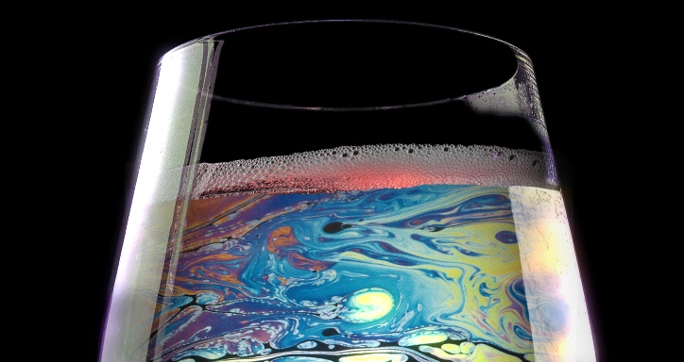
Agnieszka Polska, „Watery Rhymes”, 2014, courtesy of the artist and ŻAK | BRANICKA

The exhibition “Ministry of Internal Affairs: Intimacy as Text” showcases a polyphony of voices in poetry and visual arts whose common mode of expression is a first person narrative and a confessional character of statements, while self-representation in language becomes a discursive practice of reflection and questioning and struggle for the artist’s subjectivity.

The exhibition observes the turn to affects, emotions and personal experience in contemporary culture in the recent years: not only in contemporary art, but also in the discourse and language of protest. Affects are viewed here as a new critical language and a new tool to pursue cultural criticism.

The show gathers a variety of first person statements: operations of words on words as well as interventions on feelings and thoughts, which adopt the form of texts, voice records, video essays and objects; works by artists who are no strangers to difficult and intimate topics, and concentrate on emotions and personal experience, blurring the borders between daily life and work, between confession and self-creation, between the storytelling and the narrator’s identity.
In an era when social practices, oriented to distance and irony, treat such categories as sincerity and authenticity with suspicion, the exhibition attempts to revive words and images as tools of self-awareness. The show poses a question about the extent to which confession can go beyond the narcissistic dimension of talking “about oneself,” and provide a transgressive source of communication and identification for the viewer.
Artists: Zuzanna Bartoszek, Hannah Black, Julien Creuzet, Lilii Reynaud Dewar, Cécile B. Evans, Dorota Gawęda i Eglė Kulbokaitė, Jakub Głuszak, Konrad Góra, Caspar Heinemann, Barbara Klicka, Aldona Kopkiewicz, Chris Kraus, Xu Lizhi, Eileen Myles, Jaakko Pallasvuo, Agnieszka Polska, Post-Noviki, Fazal Rizvi, Bunny Rogers, Steve Roggenbuck, Megan Rooney, Andrzej Szpindler, Julia Szychowiak, Adela Truścińska, Amalia Ulman, Audrey Wollen, Dena Yago, Ewa Zarzycka

Opening hours: Tuesday–Sunday 12 PM–8 PM
Admission free
Guided tours in English and Russian: Saturdays 2 PM
Guided tours in Polish: Saturdays 4 PM
www.artmuseum.pl

