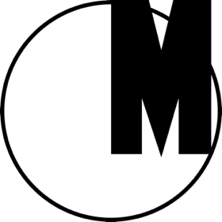
ON THE TIP OF THE TONGUE
PERFORMANCE AND THE WAR OF WORDS

21 September–30 October 2016
Museum of Modern Art in Warsaw
ul. Pańska 3, 00-124 Warsaw, Poland
Admission free

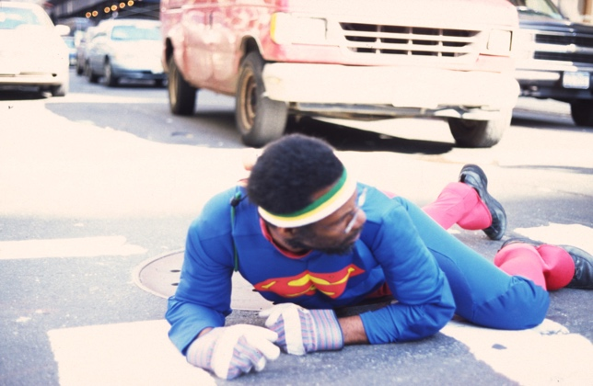
Pope.L, “The Great White Way: 22 Miles, 9 Years, 1 Street (Whitney version #2),” 1990, video still
© Pope.L. Courtesy of the artist and Mitchell-Innes & Nash, New York

“On the Tip of the Tongue: Performance and the War of Words” is a six-week program beginning at the end of September at the Museum of Modern Art in Warsaw, entirely dedicated to performance and an expanded reflection on the issue of communication. It seems that language has recently lost the ability to capture reality. And it is not only that the words are losing their meanings but they have also ceased to actually fit what they are trying to describe as a result of their many abuses, rhetorical games, or mockery. Instead of being a common area of a possible compromise, language has recently become very aggressive, egoistic, and inexpressive. It has thus lost its communicative function and, furthermore, it is unable to capture the dynamics of the current changes.

“On the Tip of the Tongue: Performance and the War of Words” is also an active take on these issues by means of references to a medium which is most sensitive to the here and now — performance. Performance enables communication with our surrounding reality, saturated with misunderstandings and conflicts. The invited artists — Cara Benedetto, Jeremiah Day, Wojciech Kosma, and Pope.L — resort to different contexts, practices, and activities. In so doing, they will be using performance as a tool that aims at capturing the changes by means of action, as language is no longer useful in articulating it.

A series of meetings and discussions with invited guests will accompany the actions of the artists. Moderated by Paweł Dobrosielski (Institute of Polish Culture at the University of Warsaw), the aim of these events will be to reflect on the devaluation of public debate in Poland, through such notions as “gender,” “politics,” “pluralism,” “the nation,” or “the left/the right,” all of which have become pervasive clichés that seem to generate connotations with an obvious constellation of values and meanings. The participating guests will consider these words in an attempt to restore their meanings and historical continuity, as well as their power in describing reality.

To coincide with “On the Tip of the Tongue: Performance and the War of Words,” the Performance Archive will be launched — a continually expanded online archive showing the wealth and the ambiguous tradition of the history of performance in Poland. The archive will be presented and problematized in a series of meetings moderated by Joanna Krakowska (Art Institute at the Polish Academy of Science) and Piotr Morawski (Institute of Polish Culture at the University of Warsaw), with invited guests.

CALENDAR

21.09 | 3–7 PM | PERFORMANCE | Cara Benedetto “Anything Cant Happen”  (open rehearsal) | ul. Pańska 3
22.09 | 3–7 PM | PERFORMANCE | Cara Benedetto “Anything Cant Happen”  (open rehearsal) | ul. Pańska 3
23.09 | 8:30 PM–12:30 AM | PERFORMANCE | Cara Benedetto “Anything Cant Happen”  (RSVP event)  To RSVP you must be a self-identified woman, or a trans-person, or their guest. RSVP to rsvp@artmuseum.pl | ul. Pańska 3
24.09 | 12–8 PM | EXHIBITION | Cara Benedetto “Anything Cant Happen”  (remains of erotic exchanges) | ul. Pańska 3
24.09 | 4 PM | CONVERSATION (ENG) | Cara Benedetto in conversation with Monika Szczukowska | ul. Pańska 3
26.09 | 6 PM | LECTURE (PL) | Beyond the Performance Archive – Zbigniew Warpechowski | ul. Pańska 3
27.09 | 6 PM | PERFORMATIVE LECTURE (PL) | Archive of Conflict | Archive of Utopia | ul. Pańska 3
29.09 | 6 PM | DISCUSSION (PL) | Index of Forbidden Words – “gender” | ul. Pańska 3
4.10 | 6 PM | EXHIBITION OPENING | Jeremiah Day “The Frank Church: River of No Return Wilderness“ | ul. Pańska 3
4.10 | 6:30 PM | PERFORMANCE | Jeremiah Day “The Frank Church: River of No Return Wilderness“ | ul. Pańska 3
5.10 | 6 PM | DISCUSSION (PL) | Index of Forbidden Words – “politics” | ul. Pańska 3
6.10 | 6 PM | PERFORMANCE | Jeremiah Day and Jakub Dymek “MAQUIS” | ul. Pańska 3
10.10 | 6 PM | CONVERSATION (PL) | Beyond the Performance Archive – Teresa Murak | ul. Pańska 3
11.10 | 6 PM | DISCUSSION (PL) | Index of Forbidden Words – “pluralism” | ul. Pańska 3
12.10 | 7 PM | PERFORMANCE | Wojciech Kosma “Episode 1 (In what kind of emotional reality would you like to live?)“ | Al. Niepodległości 159
13.10 | 7 PM | PERFORMANCE | Wojciech Kosma “Episode 2 (In what kind of emotional reality would you like to live?)“ | Al. Niepodległości 159
14.10 | 7 PM | PERFORMANCE | Wojciech Kosma “Episode 3 (In what kind of emotional reality would you like to live?)“ | Al. Niepodległości 159
15.10 | 7 PM | PERFORMANCE | Wojciech Kosma “Episode 4 (In what kind of emotional reality would you like to live?)“ | Al. Niepodległości 159
17.10 | 6 PM | CONVERSATION (PL) | Beyond the Performance Archive – Ewa Partum | ul. Pańska 3
18.10 | 7 PM | LECTURE (PL) | Beyond the Performance Archive – Tomasz Sikorski | ul. Pańska 3
20.10 | 6 PM | DISCUSSION (PL) | Index of Forbidden Words – “the right / the left” | ul. Pańska 3
24.10 |  | PERFORMANCE | Pope.L “Spot”
25.10 | 6 PM | PERFORMATIVE LECTURE (PL) | Archive of Conflict | Archive of Utopia | ul. Pańska 3
26.10 | 18.00 | DISCUSSION (PL) | Index of Forbidden Words – “nation” | ul. Pańska 3
29.10 | 6 PM | PERFORMANCE (PL) | Beyond the Performance Archive – Roman Stańczak | ul. Pańska 3

On the Tip of the Tongue: Performance and the War of Words
Artists: Cara Benedetto, Wojciech Kosma, Jeremiah Day, Pope.L
Curators: Marta Dziewańska, Magda Lipska, Natalia Sielewicz, Monika Szczukowska
Curators of the Performance Archive: Robert Jarosz, Łukasz Mojsak, Łukasz Ronduda
Production: Katarzyna Białach
Partners: Institute of Polish Culture at the Unversity of Warsaw, Trans-Fuzja, Szustow. Kultura i Komunikacja, Studio Niepodległości 159
Legal advisor: CMS Law Tax
Patron of the Museum Collection: Fundacja Zwierciadło
Media patrons: Zwierciadło, Gazeta Wyborcza, Wyborcza.pl Warszawa, Co Jest Grane, TVP Kultura, TOK FM

