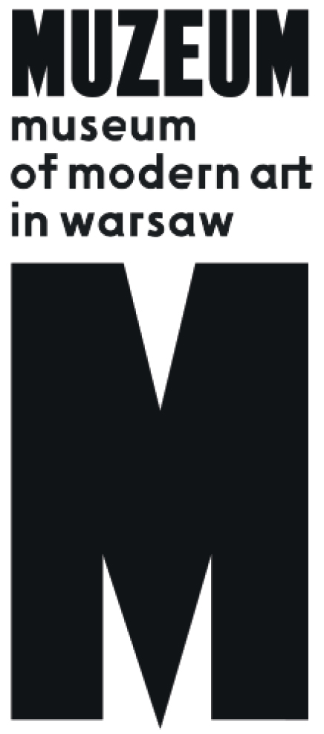 | Daniel Rycharski  FEARS  215.02 – 22.04.2019  Museum on the Vistula  Wybrzeże Kościuszkowskie 22  opening: 15.02.2019, 19.00

Museum of Modern Art in Warsaw presents the first solo exhibition of Daniel Rycharski, an artist working at the intersection of diverse social worlds: countryside, queer culture, and faith community.

The exhibition "Daniel Rycharski: Fears" is an overview of the work of an artist who develops his own form of cooperation with the local society in his hometown of Kurówko. He creates a proposal for artistic activity by raising for discussion the issue of identity and the boundaries of membership in a religious community. His artistic practice uncompromisingly and innovatively synthesizes the paradoxes of the current reality. In his works he manages to convey seemingly contradictory experiences: being an artist and believer, a gay working in a conservative society on new means of emancipation from rote forms of religion. This cross-section exhibition of Rycharski’s works is part of the museum’s programme seeking new languages for describing the world around us, an attempt to draw attention to one of the most interesting and radical artistic attitudes in recent time.

During his studies at the Kraków Academy of Fine Arts, Rycharski began to examine the visual culture and identity of contemporary rural areas. Since then his works have complicated the image of the countryside, seeking forms of expression for other social experiences and visions. The lessons from Kurówko remain a touchstone for Rycharski in his approach to art and communication with audiences. His personal biography and family situation serve as a point of departure for the artist to take up more universal themes important from the perspective of a society experiencing conflicts connected with the return (or endurance) of religion as an instrument of political mobilization and polarization. As an artist cooperating with such diverse groups as agricultural and religious associations, a club of rural housewives, and LGBT+ activists, in his works he wrestles with numerous social fears and prejudices.

Rycharski’s bold approach to faith and Christianity, which is unparalleled in Polish art, is currently the driving force of his artistic practice. The items gathered for the exhibition tell the story of the actions of an artist who moves from a desire to organize a grass-roots revolution and attain equal rights for LGBT+ people in the Church, to practising faith by his own rules. Grounded in religion by various institutions and family, he seeks within a given set of concepts and values a new version of a project of liberation which would embrace outcasts and which he calls “Christianity without religion.”

The exhibition at the Museum of Modern Art in Warsaw seeks a common nerve running through the actions undertaken by the artist in cooperation with rural inhabitants and identity projects growing out of the foundation of those contacts.

Rycharski’s endeavours propose an original language of queer art, not unmindful of class sensitivity, through which the artist offers to reorganize our way of thinking about political divisions, to find another path to articulation of conflicts. His project seeks to replace the existing vocabulary and open up a fresh discussion of old values in art, but also determinedly pushes toward a new, inclusive way of thinking about relationships. Expressing himself through actions and situations, Rycharski does not abandon the world of objects, but endows them with a strong charge of emotion and existential experience by foregrounding the materiality of the object and its history.

"Daniel Rycharski: Fears" is a report from over a decade of work by an artist who more than meets the demand to seek an alternative, while drawing richly from codes of popular culture, developing a new interpretation of the art of cooperation bordering on activism, political initiative and instigation.

Online catalogue: rycharski.artmuseum.pl/en

Curator:
Szymon Maliborski
Project management
Joanna Turek
Key visual
Krzysztof Pyda
Promotion
Iga Winczakiewicz, Kacha Szaniawska, Daniel Woźniak, Magdalena Zięba

