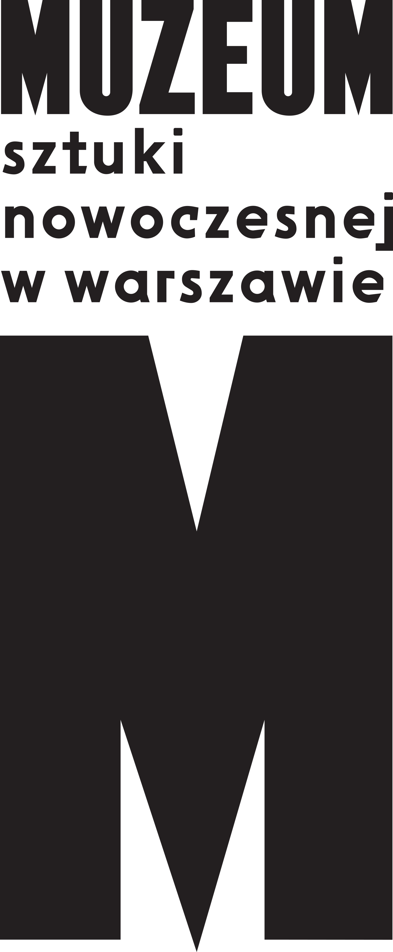 | PRESS RELEASE  13.01.2021  Henryk Streng / Marek Włodarski  and Jewish-Polish Modernism  5 February - 9 May 2021  Museum of Modern Art in Warsaw  Wybrzeże Kościuszkowskie 22

He was born Henryk Streng and died as Marek Włodarski. He was a student of Fernand Léger and friend of Bruno Schulz. Although he studied in Paris, it was multicultural Lwów (now Lviv, Ukraine) that was his greatest source of inspiration. Through his works, we become immersed in the artistic atmosphere of the city. The Museum of Modern Art in Warsaw warmly invites you to the exhibition Henryk Streng / Marek Włodarski and Jewish-Polish Modernism, which opens on 5 February 2021.

Streng / Włodarski’s life and works are difficult to describe using established concepts. They transcend existing frameworks and demand ever new readings. For Piotr Słodkowski, curator of the exhibition, “by drawing on the work of Streng / Włodarski and other related artists, it becomes possible to illustrate the interconnection of three fascinating phenomena: Modernism, socially engaged art that sought to change the world, and Polish-Jewish or Jewish-Polish cultural identity.” The exhibition will be accompanied by descriptions in Polish, Ukrainian and English.

Streng / Włodarski
The story of the artist’s life and works is fascinating, ambiguous and multi-layered. He was born Henryk Streng in Lwów in 1898 and died as Marek Włodarski in Warsaw in 1960. He was a Pole, Jew, and Holocaust survivor, a Lwowian and a Varsovian. In Paris, he studied under Léger and was fascinated by Breton. In Lwów, he co-founded the avant-garde Artes group and was friends with Debora Vogel and Bruno Schulz. He experienced the Stalinist and Nazi occupations during World War II. He went into hiding and escaped to Warsaw. He was arrested and sent to the Stutthof concentration camp. After the war, he played a key role in the development of Polish contemporary art and was a professor at the Academy of Fine Arts in Warsaw.

Modernism / Socialist Realism
He learned from the best while always seeking his own novel, unique paths. In the late 1920s and early 1930s he created Surrealist works and after the war he was one of the most influential figures in the field of Modern art. He experimented with socially engaged art, developing a model of New Realism in the 1930s, before twenty years later finding inspiration in Socialist Realism. This exhibition at the Museum of Modern Art in Warsaw demonstrates that it is difficult to apply the traditional opposition of Modernism versus Socialist Realism in relation to artistic life in that period, and particularly the works of Streng / Włodarski. The curator Piotr Słodkowski suggests using instea the fluid category of Socialist Modernism, adding that “Streng / Włodarski’s biography offers visitors a starting point for tracing the complex relations between art, identity and war.”

Paris? No, it’s Lwów!
Until now, Streng / Włodarski’s works have been described primarily from the perspective of how they were shaped by his studies in Paris under Léger. However, the artist also drew extensively on Jewish culture and the traditions of Lwów. The Museum’s exhibition therefore shifts the focus by bringing to the fore the significance of local ideas and experiences of Modernism and modernity. “For Streng / Włodarski, Lwów was the greatest source of inspiration – its suburbs and ordinary inhabitants. The exhibition also includes, for example, street photography and films from the interwar period, as well as recording of traditional Lwów songs. We trace these resonances through Streng’s works,” explains Piotr Słodkowski.
Instead of his most famous works, those produced during his studies in France, it is Streng / Włodarski’s wartime works that form the focal point of the exhibition. They offer the key to understanding his life and the transformation of his identity.

Holocaust identity
The exhibition features rarely-seen drawings and works on paper that Streng / Włodarski produced while in hiding on the ‘Aryan side’ (beyond the Ghetto), as well as objects created in the camp and postwar art. His interwar-era works are visibly marked by his efforts to efface the name Streng from them. They offer powerful testimonies to the artist’s abandonment of his existing identity.
The exhibition Henryk Streng / Marek Włodarski and Jewish-Polish Modernism will run from 5 February to 9 May 2021 at the Museum on the banks of the Vistula. Should the COVID-19 pandemic prevent visitors from coming in person, the Museum will enable online viewings in a series of special tours and other accompanying events. In keeping with our usual practice, the Museum will invite members of the public in all age groups to take part in numerous educational events offering insight into the key ideas and concepts related to the art of Streng / Włodarski and his contemporaries. In April, researchers from around the world will participate in an international academic conference on the subject of socially engaged art and global Socialist Realism.
With the conclusion of the exhibition in Warsaw, Henryk Streng / Marek Włodarski and Jewish-Polish Modernism will transfer to the National Museum in Lviv, Ukraine, where it will be on show from 30 May to 1 August.

Exhibition „Henryk Streng / Marek Włodarski and Jewish-Polish Modernism”
5 February - 9 May 2021
Wybrzeże Kościuszkowskie 22, Warsaw
curator: Piotr Słodkowski

Press kit: prasa.artmuseum.pl/en
Museum of Modern Art in Warsaw: artmuseum.pl/en
Online catalogue: streng.artmuseum.pl
Media enquires to:
Józefina Bartyzel
jozefina.bartyzel@artmuseum.pl
+48 695 492 970

