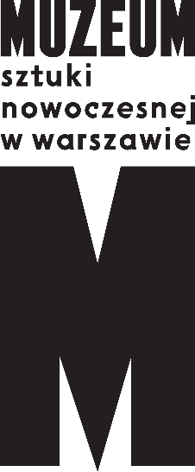 | Press Info, 01.09.2021  How to Make a School?  13th edition of the  WARSAW UNDER CONSTRUCTION festival  08.10 – 7.11. 2021  Wybrzeże Kościuszkowskie 22

Designing spaces, and the learning process: architecture and education. An exhibition, historic and contemporary school designs, architectural tours, a retreat for educators, workshops, discussions. All at a time of heated debate over the future of public education in Poland. The 13th edition of the WARSAW UNDER CONSTRUCTION festival is launching under the title “How to Make a School?”
This year’s edition of the event, traditionally focusing on a selected aspect of architecture, is devoted to trends in designing spaces for education. The curators of WARSAW UNDER CONSTRUCTION 13 are Szymon Maliborski and Paweł Brylski, both affiliated with the Museum of Modern Art in Warsaw (MSN). The festival they have prepared continues the tradition of WARSAW UNDER CONSTRUCTION: on one hand it actively contributes to commentary on current events, and on the other is an event devoted to urban design. The urban design aspect is also vital for the museum in the context of the ongoing construction of its new home on plac Defilad.
The exhibition and numerous events accompanying the 13th edition of the festival will examine various architectural practices in the light of urban transformation and will serve as an invitation to discuss methods of education and changes needed in the educational process. The team organizing the festival want to point to the challenges and prognoses for the architecture and life of schools, and to help develop scenarios for action by institutions and individuals, as well as “toolkits” for teachers.
As Szymon Maliborski explains, “We pose the question in the title at the time of a crisis in education intensified by the pandemic. But we realize that problems due to shortages of places, staff and funds, or political tensions, have occurred numerous times before and were managed in various ways. Alongside the question How to Make a School? we also pose the questions: Who and what is a school for? How to change pedagogical models, to redirect education from imparting knowledge to cultivating competencies?”
The festival began with the Retreat for Educators (16–28 August), in which teachers worked on their own strengths and learned techniques for fostering their own wellbeing. Soon weekend architectural tours will begin for anyone interested in historic and contemporary school buildings (from 5 September, for the following nine weekends), as well as the online series of films entitled The Art Teacher (broadcast on the museum’s social media sites). On Friday, 8 October, the exhibition accompanying WARSAW UNDER CONSTRUCTION 13 will open at the Museum on the Vistula (8 October – 7 November), supplemented as usual by a rich programme of meetings, discussions, and additional activities.
The exhibition and accompanying events are designed to encourage contemplation on the kind of education we need in the future and the features that the accompanying architecture should have. Selected historical and contemporary projects will be a starting point for discussions of the role of the school in building social competencies, as well as a pretext for inquiring into the role of the school in the local community. As the curators put it, “Design and education are both excellent examples of team disciplines.” We invited the National Institute of Architecture and Urban Planning, the National Digital Archive, the City of Warsaw Architecture and Spatial Planning Department, the Polish Teachers’ Union, and numerous specialists to cooperate in the 13th edition of WARSAW UNDER CONSTRUCTION. The festival consultants on educational issues are Justyna Suchecka, Przemysław Sadura and Ewa Radanowicz, and the consultants on architecture include Maria Sołtys, Michał Pszczółkowski, Grzegorz Piątek, and architectural studios who design projects for education. Part of the programme for young people will be carried out with Zuza Karcz, a young artist raising issues of psychological wellness of people within the education process and the situation of LGBT+ students. Writer and graphic artist Marcin Wicha, in cooperation with Maciej Chodziński, will prepare the installation Education—Enlightenment—Illumination, focussing on the historic role of education and the metaphor of teaching as spreading light in the darkness. The festival will also include a museology conference devoted to the relations between schools and museums and the role of space in education (Museum Educators Forum, 15 and 29 October).
The exhibition will feature works by such artists as Karolina Wojtas, Jaśmina Wójcik, Anna Grzymała, Paulina Włostowska, Marcin Chomicki and Justyna Wencel. An entirely new element of this exhibition will be a second exhibition, or to be more precise, 10 ready scenarios awaiting execution, i.e. the pilot project for artistic cooperation Formy podstawowe [Fundamental Forms], prepared by Sebastian Cichocki and Helena Czernecka. The curatorial team, along with invited artists (including Paweł Althamer, Sharon Lockhart and Goshka Macuga, among others), developed 10 sets of instructions for preparing an exhibition, and invited 10 schools whose communities will carry out these instructions, first with the support of museum staff and then on their own. Fundamental Forms was created thanks to cooperation between the museum and the Roman Czernecki Educational Foundation. It is a new project which will be carried out regularly in the future.
The launch of the latest book from the museum’s publishing arm Wydawnictwo MSN, Witajcie w świecie bez architektów [Welcome to a World without Architects], by Jakub Szczęsny (on sale from 22 October) will also be held during the festival. In the book, the creator of the Keret House and popularizer of design uses a story of anonymous builders to show us the ethical dimension of architecture and the importance of context and existing conditions in the design process.
WARSAW UNDER CONSTRUCTION is a festival consistently employing architectural and historical issues to pose current questions. This year will be no different. According to Paweł Brylski, “The task of the exhibition is not so much to diagnose difficulties, but first and foremost to seek solutions and remedial strategies. The school is a microcosm of society. Who we will be depends on what our school is like.”

Project financed by the City of Warsaw.

How to Make a School?
13th edition of the WARSAW UNDER CONSTRUCTION festival
08.10 – 7.11. 2021
Opening: 8.10, 18.00
Wybrzeże Kościuszkowskie 22

Opening hours:
Monday-Friday 12.00-20.00
Saturday 11.00-20.00
Sunday 11.00-18.00

Museum of Modern Art in Warsaw:
artmuseum.pl/en
WARSAW UNDER CONSTRUCTION festival:
warszawawbudowie.pl
Press kit:
prasa.artmuseum.pl

Media contact:
Marta Bartkowska
marta.bartkowska@artmuseum.pl | 501 275 126

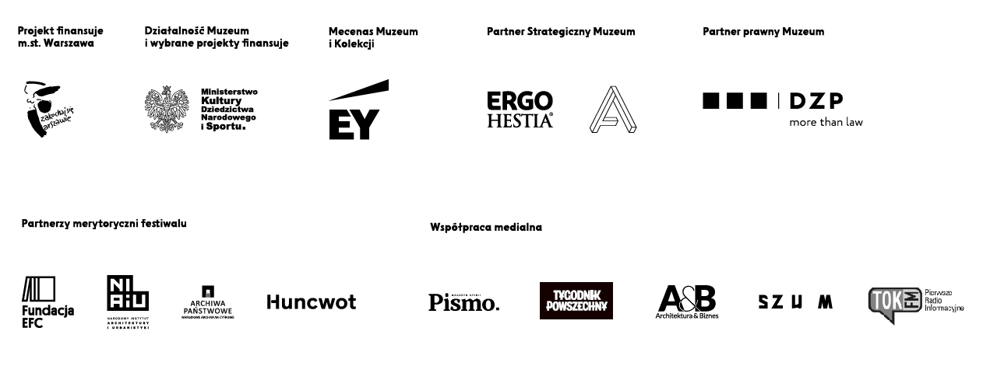
Curators
Paweł Brylski, Szymon Maliborski
Contributors
Bujnowski Architekci, Marta Baranowska, Maciej Chodziński, Marcin Chomicki & Justyna Wencel, Katarzyna Domagalska, Marta Ejsmont, Marta Florkiewicz-Borkowska, Zofia Gramz, Anna Grzymała, Zuzanna Karcz, Paweł Krajewski, Grzegorz Mika, Dorota Obidniak, Witek Orski, Grzegorz Piątek, Maciej Siuda Pracownia, Katarzyna Przezwańska, Michał Pszczółkowski, Ewa Radanowicz, Przemysław Sadura, Wilhelm Sasnal, Konrad Smoleński, Maria Sołtys, Konior Studio, XYstudio, Justyna Suchecka, Jakub Szczęsny, Marcin Wicha, Cezary Wierzbicki, Katarzyna Witt, Paulina Włostowska, Karolina Wojtas, Patrycja Wojtas, Jaśmina Wójcik, Hanna Zwierzchowska
Festival team
Anna Grajewska, Dominika Jagiełło, Marta Skowrońska-Markiewicz, Marta Przybył
Production
Anna Kobierska, Weronika Orłowska, Paweł Wójcik,
Key visual
OKI OKI Studio
Graphic design of the exhibition
Maciej Chodziński, Katarzyna Łygońska
Managing editor
Aleksandra Urbańska
Translation
Chris Smith, Piotr Szostak
Communication
Marta Bartkowska, Józefina Bartyzel, Anna Szałas, Iga Winczakiewicz
Webdesign
Huncwot
Public program coordinator
Paweł Nowożycki
Educational program
Marta Baranowska, Katarzyna Domagalska, Marta Skowrońska-Markiewicz, Marta Przasnek, Marta Przybył, Katarzyna Witt, Hanna Zwierzchowska
Exhibition architecture
XYstudio
Partners of the festival
Narodowy Instytut Architektury i Urbanistyki, Edukacyjna Fundacja im. Romana Czerneckiego, Narodowe Archiwum Cyfrowe, Huncwot
Cooperation
Biuro Architektury i Planowania Przestrzennego m.st. Warszawy
Fundacja Orange

