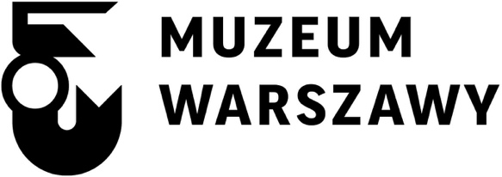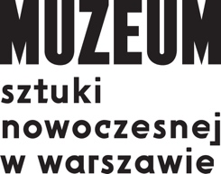

RADICAL PEDAGOGIES:
RECONSTRUCTING ARCHITECTURAL EDUCATION

An exhibition presented as part of the 7th WARSAW UNDER CONSTRUCTION
Festival organized by the Museum of Modern Art in Warsaw
and the Museum of Warsaw
October 12–November 10, 2015
Opening: October 12, 6 pm (introductory lecture), 8 pm (opening)
Venue: Faculty of Architecture, Warsaw University of Technology
Koszykowa 55, Warsaw
Opening times: Tuesday–Sunday, 12pm–8pm
The exhibition “Radical Pedagogies: Reconstructing Architectural Education” presents an atlas of intense but short-lived experiments in architectural education that profoundly transformed the landscape, methods and politics of the discipline in the post-WWII years. As challenge to normative thinking, they questioned, redefined, and reshaped the postwar field of architecture. These experiments are radical in the literal meaning from the Latin radix (root), the basis or foundation of something. These new modes of teaching shook foundations and disturbed assumptions, rather than reinforce and disseminate them. They operated as small endeavors on the fringes of institutions but had long-lasting impact. Much of architectural teaching today still rests on the paradigms they introduced.
This is the third edition of “Radical Pedagogies” exhibition. Earlier versions of this show were presented at the 3rd Lisbon Architecture Triennale (2013) and the 14th Venice Biennale of Architecture, curated by Rem Koolhaas (2014), where it was awarded a Special Mention. For the occasion of its presentation in Warsaw, the exhibition opens up new directions and a new density of global interconnections. Eastern Europe, Africa, East Asia and Australasia become the protagonists, opening new insights into pedagogical experimentation after 1945.
“Radical Pedagogies” is an ongoing multi-year collaborative research project led by Beatriz Colomina with a team of Ph.D. students of the School of Architecture at Princeton University. It has so far involved three years of seminars, interviews, archival research, guest lectures and almost 80 contributors from more than two dozen countries. In this, and similar research projects conducted by the Ph.D. program at Princeton, architecture history and theory are taught and practiced as an experiment in and of themselves, exploring the potential for collaboration—in what is often taught to be a field of individual endeavor.
Coinciding with the 100th anniversary of the Warsaw Faculty of Architecture, the installation in the exhibition pavilion of the school presents an “open archive” of 74 case studies that encourages debate regarding the history and future of architectural pedagogy. Conceived as an interactive platform, the exhibition incorporates take-away texts, facsimiles, original publications and teaching documents, archival films, and implements interactive features through augmented reality.
More information at http://wwb7.artmuseum.pl/en

Curated by:
Beatriz Colomina
Evangelos Kotsioris

Curatorial cooperation:
Britt Eversole
Ignacio G. Galán
Anna-Maria Meister
Federica Vannucchi
and other PhD students of the School of Architecture at Princeton University

Curatorial cooperation on behalf of the festival:
Aleksandra Kędziorek

Exhibition design:
Cristóbal Amunátegui, Alejandro Valdés of Amunátegui Valdés Architects

Graphic Design:
Pablo González, Smog

Multiplatform publishing concept:
Ethel Baraona, César Reyes of DPR-Barcelona

The 7th WARSAW UNDER CONSTRUCTION Festival was organized thanks to financial support of capital city of Warsaw

Partners:
Faculty of Architecture, Warsaw University of Technology
Princeton University – Program in Media and Modernity
Polish Institute in Stockholm
Culture.pl

Contact:
Museum of Modern Art in Warsaw Museum of Warsaw
ul. Pańska 3 Rynek Starego Miasta 28-42
00-124 Warszawa 00-272 Warszawa
www.artmuseum.pl www.muzeumwarszawy.pl
prasa@artmuseum.pl
tel. +48 22 596 40 23
tel. +48 535 500 552

