2018 AT MUSEUM OF MODERN ART IN WARSAW
EXHIBITION AT THE MUSEUM ON THE VISTULA
(WYBRZEŻE KOŚCIUSZKOWSKIE 22, WARSAW)

The Other Trans-Atlantic. Kinetic and Op Art. In Eastern Europe and Latin America 1950s – 1970s
17.11.2017 – 11.02.2018

Edi Hila. Painter of Transformation

2.03 – 6.05. 2018
What Is Enlightenment. 200 Years of the University of Warsaw Library Print Collection
18.05 – 17.06

Final exhibition in the 17th edition of the Hestia Artistic Journey competition

25.06 – 4.07

A Beast, a God, and a Line

20.07 – 7.10

Women on Aeroplanes

25.10 – January 2019

ADDITIONAL PROJECTS:

Department of Presence. Public program of the Museum of Modern Art in Warsaw February – December 2018
10th edition of the festival WARSAW UNDER CONSTRUCTION
September – November 2018
Museum at the Open’er 2018
4-7.07.2018
Bródno Sculpture Park. Chapter X: Contemporary Art Biennale
May – September 2018
The Other Trans-Atlantic: presentation in Moscow
17.03 – 09.05.2018
The Other Trans-Atlantic: presentation in Sao Paulo
25.07 – 30.09.2018

The new year at the Museum of Modern Art in Warsaw will feature four major exhibitions at the Museum on the Vistula, the Department of Presence—a new public program at the Museum on Pańska Street—and the 10th edition of both the Warsaw Under Construction festival and the Bródno Sculpture Park.
Edi Hila  Painter of Transformation  2 March – 6 May 2018  Curators: Kathrin Rhomberg, Erzen Shkololli, Joanna Mytkowska | 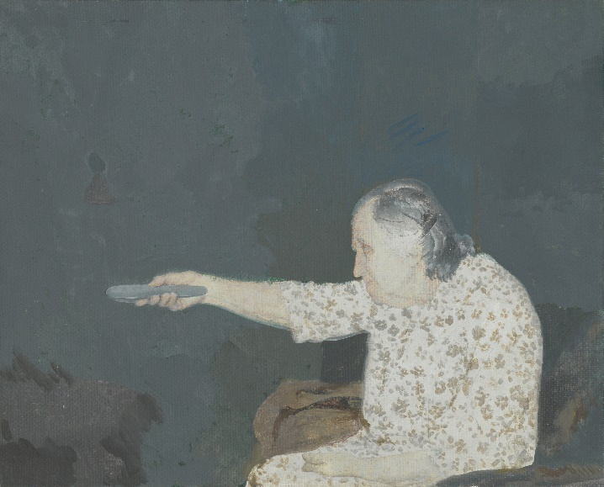
The Museum of Modern Art in Warsaw is preparing the first retrospective exhibition of the Albanian painter Edi Hila, one of the last neglected masters from Eastern Europe.
Hila was born in Shkodër and works in Tirana. He is affiliated with the Tirana Academy of Fine Arts, where he is an influential teacher.
Educated in Shkodër, a city with its beginnings in the ancient world, Hila has always had access to the roots of classical culture. During his studies in the 1960s he experimented timidly with deformation. In 1972 he painted "Planting Trees", a pleasant picture rendered slightly unreal through the use of colours. Because it departed from the social realist doctrine in force at the time, this painting was used as the pretext for sentencing him to a re-education camp. For several years, forced to live in the countryside and work on a chicken farm, he was practically cut off from the ability to practise painting. He produced numerous drawings at that time, first and foremost the series "Poultry" (1975–1976), documenting rural life, harrowing in the raw realism of its presentation, with existential undertones. In the 1990s, seeking his own path back to painting, Hila carefully observed life evolving after the fall of the Hoxha regime and tried to depict the realities of social transformation. In the groundbreaking series "Comfort" (1997), the artist captures the inability to satisfy the need for comfort promised to the new society.
He primarily creates series treating a selected theme over several paintings. The most important of Hila’s series include "Paradox" (2000–2005), "Relations" (2002–2014, "Threat" (2003–2009), "Roadside Objects" (2007–2010), "Penthouses" (2013), "Boulevards" (2015) and "A Tent on the Roof of the Car" (2017). The realism of his painting is distinct, based on careful observation of detail, which he exploits to convey the psychological truth of the observed phenomenon.
Hila carefully selects the themes for his painting series. They possess the strength of authenticity of everyday observation as well as the universality of the existential principle. In his version, this strips the transformation in Eastern Europe of accident or adventure typical of many presentations, and gives it the weight of distilled general truths, as if he were its final chronicler. One of the reasons for such radical reduction may be Hila’s leaning toward classicism, a fascination with Renaissance sources of painting. It is as if modernism has evaporated from his field of interest and there are no dilemmas of modernity. This is why the transformation, in collision with the classical tradition of painting and balance understood in the distant spirit of the Renaissance, conveys so clearly the disruption and attack on harmony and order. On the other hand, it is rooted in human dilemmas that are hard to conceal, even with a veneer of modernization.
Edi Hila’s exhibition at the Museum of Modern Art in Warsaw fits within a series of exhibitions devoted to overlooked artists from Eastern Europe. Over the past few years we have prepared monographic exhibitions of Ion Grigorescu, Július Koller and Mária Bartuszová, and carried out projects with Sanja Iveković and Tomislav Gotovac. But this project extends beyond scholarly curiosity or historical necessity. The reason we are addressing Hila’s oeuvre at this time is the acute currency of an artist who refused to be deceived by the trappings of the transformation, always tracing the subcutaneous threats it carried with it.

What Is Enlightenment?
200 Years of the University of Warsaw Library Print Collection
18 May – 17 June 2018
Curators: Łukasz Ronduda, Tomasz Szerszeń

The exhibition “What Is Enlightenment?” will be based on a dialogue between exhibits from the historic collection of King Stanisław August from the University of Warsaw Print Collection and the works of contemporary artists created especially for the exhibition—a dialogue between the Polish Enlightenment and modernity. The main concept is a reflection on the currency of the Polish Enlightenment, a moment of rapid development of science, state reforms, and the birth of a modern society; on its unfinished character; and finally on the eclipse of Enlightenment values diagnosed around the world. Viewed through this lens, the Polish Enlightenment and modernity would both look like historic moments to one another. Seeking the Enlightenment roots of the print collection, the curators, along with Goshka Macuga and other invited artists, inquire into the contemporary possibilities for interpretation of a historic collection.

A Beast, a God, and a Line  20 July – 7 October 2018  Curator: Cosmin Costinas | 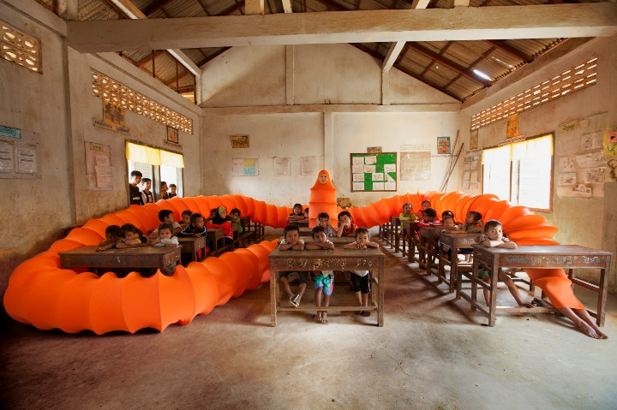
A Beast, a God, and a Line is an exhibition developed by Cosmin Costinas, director of Para Site in Hong Kong, based on research on the flow of political and social ideas in Bengal, a historic region of South Asia.
This project raises the most burning issues defining the present situation in the region, such as the radicalization and politicization of religious movements (for example the Islamic Jihadism in many countries of the region, or evangelical revival movements among native communities in the Philippines), political populism, the weakening of liberal democracies, as well as various attempts to create new state narratives alternative to the modern West and the colonial past. These issues are considered from the historical perspective of “migrations” of objects and ideas across territories from Hawaii to New Zealand and Madagascar, centring on Taiwan, Indonesia, Malaysia and the Philippines. This history reaches from the era of Austronesian sea trade, through European colonialism, to intellectual and political visions from the time of struggles for independence.
The core of the exhibition is made up of works by contemporary artists, such as Apichatpong Weerasethakul, Nabil Ahmed, Nguyen Trinh Thi, Sawangwongse Yawnghwe, Sheela Gowda, Sheelasha Rajbhandari, Simryn Gill, Thao-Nguyen Phan, Anida Yoeu Ali, Raja Umbu and Su Yu Hsien. Collections of textiles, as a witness to the transfer of forms, ornaments, concepts and beliefs to and from Bengal, provide the framework and background for presentation of the modern works, constructing their historical and current contexts. The exhibition is divided into chapters devoted to various issues and forms of visual expression, from narratives connected with the export of textiles and godowns (stores and warehouses typical for the Asia Pacific region), to the work of contemporary Filipino craftsmen.
The exhibition, prepared in cooperation with the Dhaka Art Summit in Bangladesh, will also be presented at Para Site in Hong Kong and TS1 in Yangon, Myanmar.

Women on Aeroplanes  26 October 2018 – January 2019  Curators: Magda Lipska, Annett Busch & Marie-Hélène Gutberlet | 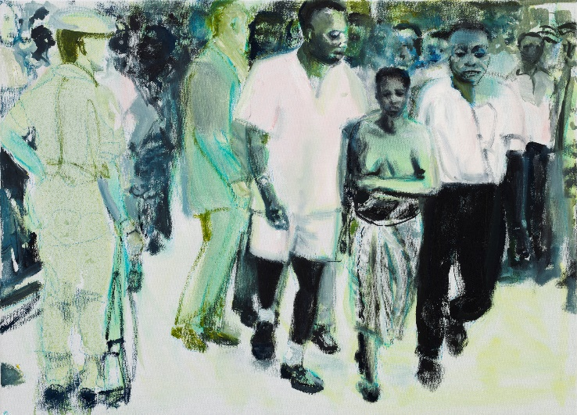
Women on Aeroplanes is an exhibition examining the (non)presence of women in 20th-century national liberation narratives. Through an analysis of visual materials from the history of independence struggles in various regions of the world from 1918 through the decolonization period after 1989, the exhibition seeks to deconstruct the fraternité dimension of independence, which in the revolutionary triad of modernity dominated both liberté and égalité, relegating women, who were often directly involved in the struggle, to the role of mute witnesses of history. Analyzing various aspects of independence histories, we show that the involvement of women in shaping independence cannot be reduced to symbolic presentations of revolution and budding statehood, but also includes political rights and power-sharing. We strive to hear women’s political claims and see their political visions for formation of the state and involvement in the collective.
The exhibition is part of the larger research project Women on Aeroplanes, realized with financial support from TURN Kulturstiftung des Bundes, in cooperation with Iwalewahaus (Bayreuth), the Centre for Contemporary Art (Lagos), ifa-Galerie (Berlin) and The Showroom (London).

Bródno Sculpture Park
Chapter X: Paweł Althamer, Goshka Macuga, Contemporary Art Biennale
May – September 2018
The main element of the 10th anniversary of the Bródno Sculpture Park is a performance/exhibition program of the Contemporary Art Biennale, prepared by Paweł Althamer and Goshka Macuga. Althamer and Macuga are among the best-known Polish artists, having presented their works at such venues as the Venice Art Biennale, Documenta in Kassel, the Berlin Biennale, Centre Pompidou in Paris, and MoMA in New York.
During the 8th and 9th editions of the Bródno Sculpture Park, residents of the local housing estate embodied the role of artists, sculpting together the monument The Burghers of Bródno. This time the Bródno district itself becomes an art exhibition. Macuga and Althamer underline the special character of the 10th edition of the Bródno Sculpture Park based on the concept of celebrating Bródno as a “found exhibition of contemporary art.” The artists’ activities across many parts of the district—happenings, tours, marches, meetings, interventions—will involve various groups of residents, accenting the specific nature of the estate. Althamer thus alludes to his earlier projects aimed at drawing attention to the conceptual, surreal or mystical nature of objects in our immediate surroundings (such as the exhibition at the Tęcza cinema in Żoliborz, presenting found objects and items lent by neighbours). One of the artist’s best-known works was carried out in a similar spirit: Bródno 2000, consisting of the illumination of that date on the façade of a block of flats on Krasnobrodzka Street using the lights from the residents’ windows. Althamer refers to this type of practice as “directing reality,” and calls the final effect a “real-time movie.” This time the scope of the project is broader, covering many elements of the estate, including allotment gardens, storefront display cases, balconies, school playgrounds, and even the interiors of private flats.
Cooperating with Althamer on this edition of the project, Goshka Macuga (living and working in London for over a decade, nominated for the Turner Prize in 2008) employs a specific working method based on the “archaeology of culture”: each new project is preceded by thorough archival and historical research, placing the project in a broader context, such as the economic conditions for art. Macuga creates installations combining the work of other artists, archival materials and found objects, merging the strategies of artist and curator.

Department of Presence
Public program of the Museum of Modern Art in Warsaw
February – December 2018
Curators: Sebastian Cichocki, Marta Dziewańska, Magda Lipska, Paweł Nowożycki, Paul B. Preciado, Łukasz Ronduda, Natalia Sielewicz, Warsaw Biennale, Kem
Coordination: Natalia Sielewicz
The Department of Presence is a new public program at the Museum on Pańska Street. It is a form of an “institution within an institution,” a non-hierarchical experimental research and educational station emerging from experiments with various forms of artistic expression to confront political, social and economic issues.
The shape of contemporary debate is determined by issues of presence and absence of themes and actors in public life. The lack of a language for describing the radical changes occurring in society, the future of Europe beyond the organization of the nation state, the crisis of migration policies, the autonomization of big cities, are burning problems of modernity undergoing progressive manipulation and disinformation in the media sphere. The Department of Presence is an attempt to start from scratch—to pose fundamental questions about the shape and language of the future.
The Department of Presence tests performative forms of engagement in a specially designed space, the heart of which is the installation Demos by Andreas Angelidakis, presented previously at Documenta 14 in Athens as part of the Parliament of Bodies program, devoted to democracy, sovereignty and hospitality in contemporary Europe. The department is divided into blocks—“residency programs” for the institution, research centres, collectives, as well as individual artists and researchers who invite the museum’s audience to negotiate positions and attitudes together.
The guests at the first edition of the Department of Presence will include Kem, a platform for contemporary choreography and performance, the newly established Warsaw Biennale, an interdisciplinary public institution combining research, activism and art, and the Spanish philosopher and writer Paul B. Preciado. The Department of Presence will also feature screenings of Syrian films, digital interventions by self-styled startups, micro-residencies of performance artists, and initiatives of the Reconstruction Group aimed at seeking new meanings and applications for artistic works and practices from the 20th and 21st centuries.

